ROAD ACCIDENT REPORT – SQL QUERIES

**CY Casualties**

SELECT SUM(number_of_casualties) AS CY_Casualties FROM road_accident

WHERE YEAR(accident_date) = '2022'

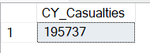

**PY Casualties**

SELECT SUM(number_of_casualties) AS PY_Casualties

FROM road_accident

WHERE YEAR(accident_date) = '2021'



**CY Casualties for Dry Surface**

SELECT SUM(number_of_casualties) AS CY_Casualties_for_Dry_Surface

FROM road_accident

WHERE YEAR(accident_date) = '2022' AND road_surface_conditions = 'Dry'

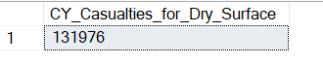

**CY Accidents**

SELECT COUNT(DISTINCT accident_index) AS CY_Accidents

FROM road_accident

WHERE YEAR(accident_date) = '2022'

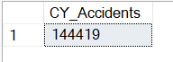

**CY Fatal Casualties**

SELECT SUM(number_of_casualties) AS CY_Fatal_Casualties

FROM road_accident

WHERE YEAR(accident_date) = '2022' AND accident_severity = 'Fatal'

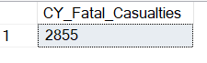

**CY Serious Casualties**

SELECT SUM(number_of_casualties) AS CY_Serious_Casualties

FROM road_accident

WHERE YEAR(accident_date) = '2022' AND accident_severity = 'Serious'

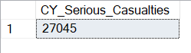

**CY Slight Casualties**

SELECT SUM(number_of_casualties) AS CY_Slight_Casualties

FROM road_accident

WHERE YEAR(accident_date) = '2022' AND accident_severity = 'Slight'

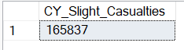

Secondary KPI’s

**Casualties by Vehicle Type**

SELECT CASE

WHEN vehicle_type IN ('Agricultural vehicle') THEN 'Agricultural'

WHEN vehicle_type IN ('Car','Taxi/Private hire car') THEN 'Cars'

WHEN vehicle_type IN ('Motorcycle 125cc and under','Motorcycle 50cc and under','Motorcycle over 125cc and up to 500cc','Motorcycle over 500cc','Pedal cycle') THEN 'Bike'

WHEN vehicle_type IN ('Bus or coach (17 or more pass seats','Minibus (8 - 16 passenger seats)') THEN 'Bus'

WHEN vehicle_type IN ('Goods 7.5 tonnes mgw and over','Goods over 3.5t. and under 7.5t','Van / Goods 3.5 tonnes mgw or under') THEN 'Van'

ELSE 'Other'

END AS vehicle_group,

SUM(number_of_casualties) AS CY_Casualties

FROM road_accident

WHERE YEAR(accident_date) = '2022'

GROUP BY

CASE

WHEN vehicle_type IN ('Agricultural vehicle') THEN 'Agricultural'

WHEN vehicle_type IN ('Car','Taxi/Private hire car') THEN 'Cars'

WHEN vehicle_type IN ('Motorcycle 125cc and under','Motorcycle 50cc and under','Motorcycle over 125cc and up to 500cc','Motorcycle over 500cc','Pedal cycle') THEN 'Bike'

WHEN vehicle_type IN ('Bus or coach (17 or more pass seats','Minibus (8 - 16 passenger seats)') THEN 'Bus'

WHEN vehicle_type IN ('Goods 7.5 tonnes mgw and over','Goods over 3.5t. and under 7.5t','Van / Goods 3.5 tonnes mgw or under') THEN 'Van'

ELSE 'Other'

END

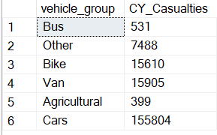

**CY Casualties and PY Casualties Monthly Trend**

**CY:**

SELECT DATENAME(MONTH,accident_date) AS Month_Name, SUM(number_of_casualties) AS CY_Casualties

FROM road_accident

WHERE YEAR(accident_date) = '2022'

GROUP BY DATENAME(MONTH,accident_date)

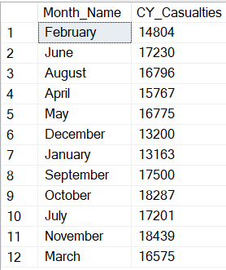

**PY:**

SELECT DATENAME(MONTH,accident_date) AS Month_Name, SUM(number_of_casualties) AS PY_Casualties

FROM road_accident

WHERE YEAR(accident_date) = '2021'

GROUP BY DATENAME(MONTH,accident_date)

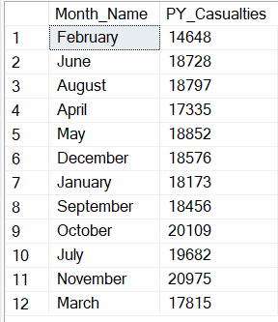

**CY Casualties by Road Type**

SELECT road_type, SUM(number_of_casualties) AS CY_Casualties

FROM road_accident

WHERE YEAR(accident_date) = '2022'

GROUP BY road_type

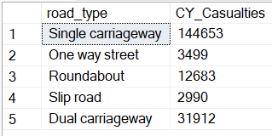

**PY Casualties by Road Type**

SELECT road_type, SUM(number_of_casualties) AS PY_Casualties

FROM road_accident

WHERE YEAR(accident_date) = '2021'

GROUP BY road_type

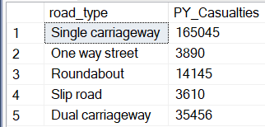

**Total Casualties by Road Type**

SELECT road_type, SUM(number_of_casualties) AS Total_Casualties

FROM road_accident

GROUP BY road_type

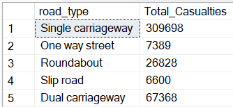

**Casualties by Urban/ Rural**

SELECT urban_or_rural_area, CAST(SUM(number_of_casualties) AS DECIMAL(10,2))*100/

(SELECT CAST(SUM(number_of_casualties) AS DECIMAL(10,2))

FROM road_accident

WHERE YEAR(accident_date) = '2022') AS PCT

FROM road_accident

WHERE YEAR(accident_date) = '2022'

GROUP BY urban_or_rural_area

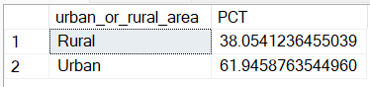

**Casualties by Light Condition**

SELECT

CASE

WHEN light_conditions IN ('Daylight') THEN 'Day'

WHEN light_conditions IN ('Darkness - lighting unknown','Darkness - lights lit','Darkness - lights unlit','Darkness - no lighting') THEN 'Night'

END AS Light_Condition,

CAST(CAST(SUM(number_of_casualties) AS DECIMAL(10,2))*100/

(SELECT CAST(SUM(number_of_casualties) AS DECIMAL(10,2))

FROM road_accident

WHERE YEAR(accident_date) = '2022') AS DECIMAL(10,2)) AS CY_Casualties_PCT

FROM road_accident

WHERE YEAR(accident_date) = '2022'

GROUP BY

CASE

WHEN light_conditions IN ('Daylight') THEN 'Day'

WHEN light_conditions IN ('Darkness - lighting unknown','Darkness - lights lit','Darkness - lights unlit','Darkness - no lighting') THEN 'Night'

END

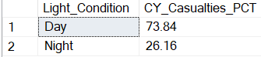

**Top 10 Locations by Number of Casualties**

SELECT TOP 10 local_authority, SUM(number_of_casualties) AS Total_Casualties

FROM road_accident

GROUP BY local_authority

ORDER BY Total_Casualties DESC

